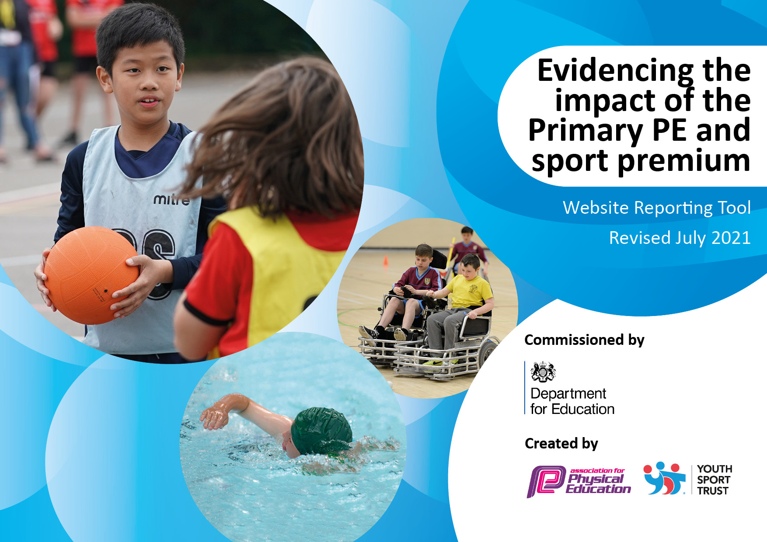
Awsworth Primary
and Nursery School

Sports Premium Funding
2022 - 2023
Total amount carried over from 2021/22 | £ 0
Total amount allocated for 2022/23 | £18,790.00
How much (if any) do you intend to carry over from this total fund into 2023/24? | £ 0
Total amount allocated for 2022/23 | £18,790.00
Total amount of funding for 2022/23. To be spent and reported on by 31st July 2023. | £18,790.00
Meeting national curriculum requirements for swimming and water safety.

What percentage of your current Year 6 cohort swim competently, confidently and proficiently over a distance of at least 25 metres? | 91%
What percentage of your current Year 6 cohort use a range of strokes effectively [for example, front crawl, backstroke and breaststroke]? | 73%
What percentage of your current Year 6 cohort perform safe self-rescue in different water-based situations? | 82%
Schools can choose to use the Primary PE and sport premium to provide additional provision for swimming but this must be for activity over and above the national curriculum requirements. Have you used it in this way? | Yes
Swimming Data
Please report on your Swimming Data below.
Details with regard to funding

Action Plan and Budget Tracking
Capture your intended annual spend against the 5 key indicators. Clarify the success criteria and evidence of impact that you intend to measure to evaluate for pupils today and for the future.

Academic Year: 2022/23 |  | Total fund allocated: £18,790.00 | Date Updated: July 2023
Key indicator 1: The engagement of all pupils in regular physical activity – Chief Medical Officers guidelines recommend that primary school pupils undertake at least 30 minutes of physical activity a day in school  Key indicator 2: The profile of PESSPA being raised across the school as a tool for whole school improvement  Key indicator 3: Increased confidence, knowledge and skills of all staff in teaching PE and sport  Key indicator 4: Broader experience of a range of sports and activities offered to all pupils  Key indicator 5: Increased participation in competitive sport |  |  |  |  | Percentage of total allocation:
1 – 12%
2 – 25%
3 – 45%
4- 10%
5 – 8%
 | Intent | Implementation |  | Impact
1 | Establish baseline activity with all F2-Y6 pupils twice a year – undertake assessment towards the beginning of the autumn term and again during the second half of the summer term  Introduce the daily activity to  get all pupils undertaking at least 30 minutes of additional activity per day.  Staff from each phase to establish a ‘pupil  challenge’ which promotes individual progression and provides for the intra-phase competition.  Additional swimming instructor support to provide opportunities for Y2 swimming sessions throughout the academic year and extend opportunities for Y6 children to meet the national curriculum requirements for swimming and water safety. | -Arrange with Premier Sport staff to come and undertake baseline activity. Distribute results to staff.  Liaise with staff in order to establish a schedule: Anomaly active boards / daily mile. Use Active Teach materials for use in both curriculum and activity time.  Liaise with LA swimming organizer to arrange for additional swimming instructor to be available. | £0  £2100  £9400 | All pupils undertake the assessment and a baseline established from which progress can be measured.  All pupils involved in 30 minutes of additional activity every day.  Tracking of children through to KS2 assessment – did they make 100% completing 25m? Also tracking using NSS stage criteria for schools attending.
2, 4, | For our children to take part in disability awareness coaching and participate in a competitive interschool sporting disability awareness events. | X 1 day wheel chair basketball coaching sessions for years 3-6 (x1 hour sessions)  X1 after school club for 20 children (Year 5)  X 1 day wheel chair basketball coaching sessions for years R-2 (x1 hour sessions)  X1 day working with another local school on an interschool wheelchair basketball competition. | £672 | Children understand the challenges and the achievements of disabled athletes. Children are exposed to a wide range of additional skills that they may not have experienced.  Development of co-operation/working in groups/desire to learn in the year group that took part in interschool competition (Year 5) | Next year, our Trust has arranged for Primaries to access a 6-week block of wheelchair basketball. This will ensure the skills are developed and children will get the opportunity to access the sport as they move through school. More opportunities for interschool competitions and participation.
2, 3 | Appointed a qualified sports coach to ensure children were accessing quality physical education lessons and staff (TA’s and teachers) were being upskilled in knowledge, understanding and techniques to raise confidence in teaching PE. | Qualified sports coach was employed for 2 day per week.  Slots were timetabled so all children and staff had access to quality PE.  Staff observed sports coach lessons to upskill and build confidence in teaching PE.  Sports coach supported newly appointed PE lead in leadership of physical education throughout school, building confidence and knowledge.  Sports coach led a variety of sports after school clubs throughout the year from R to Year 6.  Sports coach led sessions to develop basic sporting skills in children who show lower attainment within lessons.  Sports coach led sessions preparing children for competitive regional and Trust wide sporting events. | £6200 | Increased confidence, self-esteem, and a real desire to learn. The enjoyment of PE increased participation in wider activities within school and after school clubs’ participation.  Lower attaining children secured fundamental sporting skills, boosting confidence to prepare them for participation in sporting events.  PE subject lead has increased confidence leading to good leadership of the subject throughout school. Staffs’ skills and knowledge of PE is increased through access to trained staff.  Awsworth pupils participate in a variety of region and Trust wide sporting competitions for example football tournaments (achieving second place in tournament), Cross country competitions (KS2U girls came second overall in the competition with individual medals also awarded). | Access to sports coach to continue in 2022-23.  Staff to take a lead in delivering PE lessons using their developing expertise (supported by Sports coach).
1, 4 | Qualified sports coach to lead two afterschool club per week for the duration of the academic year, from Year 1 to Year 6. Children to access quality sports sessions, developing their skills in a variety of different sports. | After school sports provision carefully planned out by SLT for the academic year.  Planning ensures all year groups in school will be able to access an after-school sporting club if they wish.  Sporting clubs were planned to support timetabled regional and Trust wide sporting competitions.  Participation of vulnerable groups in afterschool sporting clubs was monitored and encouraged. | £4800 | Children are more skilled in a variety of sports.  Participation in after school clubs throughout school is high. 84% of all children attended at least one after school club this year. 85% of PP children attended at least one after school club this year. | Access to continue next year.  Children to be surveyed to ascertain which sporting activities they would like to participate in. This information to be used as part of the ongoing planning of after school sporting activities.
4 | Bikeability - Children in all of KS2 offered the opportunity for 2 hours (per class) of Level 2-3 cycle instruction provided by Via East Midlands. | Sessions offered for EYFS through balance bikes – This cost is used to pay for these sessions. For 3/4 (Spring) and Year 5/ 6 pupils (Autumn). | £2100 | Participation levels high in both Year 5 and year 6. Children have increased road and cycle safety.  All pupils in EYFS access to balance bikes. | Bikeability will continue to be offered to all pupils in KS2 to ensure they have basic bike skills.
4 | To provide UKS2 catch up swimming sessions for identified children who have not achieved the required level to ensure a greater % of our children achieve the expected standard in swimming by the end of KS2. | X6 week catch up swimming sessions. Children identified from Year 6. | £1200 | 85% of our current Year 6 cohort have achieved the expected standard in swimming. | Target of 90% set for next year’s year 6 cohort.
5 | Swimming Gala - To provide additional coaching and practice time for children who show high attainment in swimming with the intention of best preparing children for the district swimming gala. | PE lead/swimming instructors/sport coach to identify pupils who would benefit from additional preparation time.  PE lead to accompany children on the practice sessions to ensure swimming gala rules and regulations are adhered to. | £200 | Individual pupils achieved success. 3 First placed medals, 4 Second and 2 Third. Overall, APS came 4th in the larger Primary schools section. | Children identified as potential participants for future gala attendance.
1, 2 | Purchasing renewed sporting equipment to ensure our children can participate and develop in a variety of sports. | Purchased new goal posts (for competitive and teaching sports), Netball nets, dodge balls, basket balls and hockey balls and other sporting equipment to ensure high quality and varied sports can be taught. | £1000 | School has the relevant equipment to ensure high quality and varied physical education. Children are able to practice and refine their skills in a number of sports using the correct equipment. | High quality equipment purchased and replenished to ensure it lasts for a number of years.
1, 2, 4 | To ensure a variety of staff led after school activities that promote physical development and wellbeing. | Chance to dance after school club led by a qualified dance teacher. Club culminated in a regional ‘Chance to Dance’ showcase of skills.  Gardening club for the infant children promoting healthy eating, sustainability and healthy lifestyle choices | £300 | Staff expertise is used to enhance our physical education extracurricular offer. Children have the opportunity to participate and excel in modern dance classes and to showcase their skills to a live audience.  Children have a deeper understanding of how to grow their own food and the importance of choosing healthy eating choices. Attendance of clubs is oversubscribed as children have desire to participate. | Planters were used to plant vegetables. These can be maintained and developed by future gardening groups.  Full time staff member is also a qualified dance teacher who is able to continue to offer the club in future years.
2, 4, 5 | School to participate in and host a number of regional and Trust wide sporting competitions.  Awsworth will participate in all the District Sports events offered. | Over the academic year, Awsworh will participate in:  Netball tournament  Football matches  Swimming  Boccia  Awsworth will also attend a number of sporting competitions hosted at other venues:  Competed in District Sports event  X2 cross country events  Regional Football tournament  Local girls football tournament  Inclusive games (KS1) at local secondary school  Regional swimming gala | £100 District Membership Travel costs for events £200  Supply costs to attend events £200 | Awsworth pupils participate in a variety of region and Trust wide sporting competitions, with some success, for example:  football tournaments.  Cross country competitions was successful with individuals placing in the top 3 in boys and girls.  Awsworth has attended all regional events. | Membership to District Sports to continue next year.  Awsworth will continue to participate in sporting competitive events both regional and Trust wide.
2, 3, 4 | To appoint an outdoor learning lead to develop our whole school outdoor learning offer. | Staff meeting time allocated for outdoor learning lead to disseminate resources and teaching ideas for outdoor learning.  Outdoor learning lead to set up termly whole school activities, for example orienteering activities.  MPT planning to highlight outdoor learning lessons per half term.  Teams file set up to share teaching resources, personal CPD websites and blogs and lesson ideas. | £0 | Teachers are confident to plan, resource and lead outdoor learning activities (at least one per half term). These are planned alongside termly learning themes. Teachers feel supported by Outdoor learning lead for advice and expertise to ensure lessons are relevant and our outdoor space is used to deliver curriculum objectives effectively.  Children are benefiting from active learning in the outdoors. | APS has agreed to use OPAL to deliver Outdoor Play and Learning.  This will carry forward to next years Sports Plan.

Signed off by A Gross
Head Teacher: | B Painter
Date: | June 2023
Subject Leader: | A Gross
Date: | January 2023
Governor: | E Owen
Date: | June 2023

