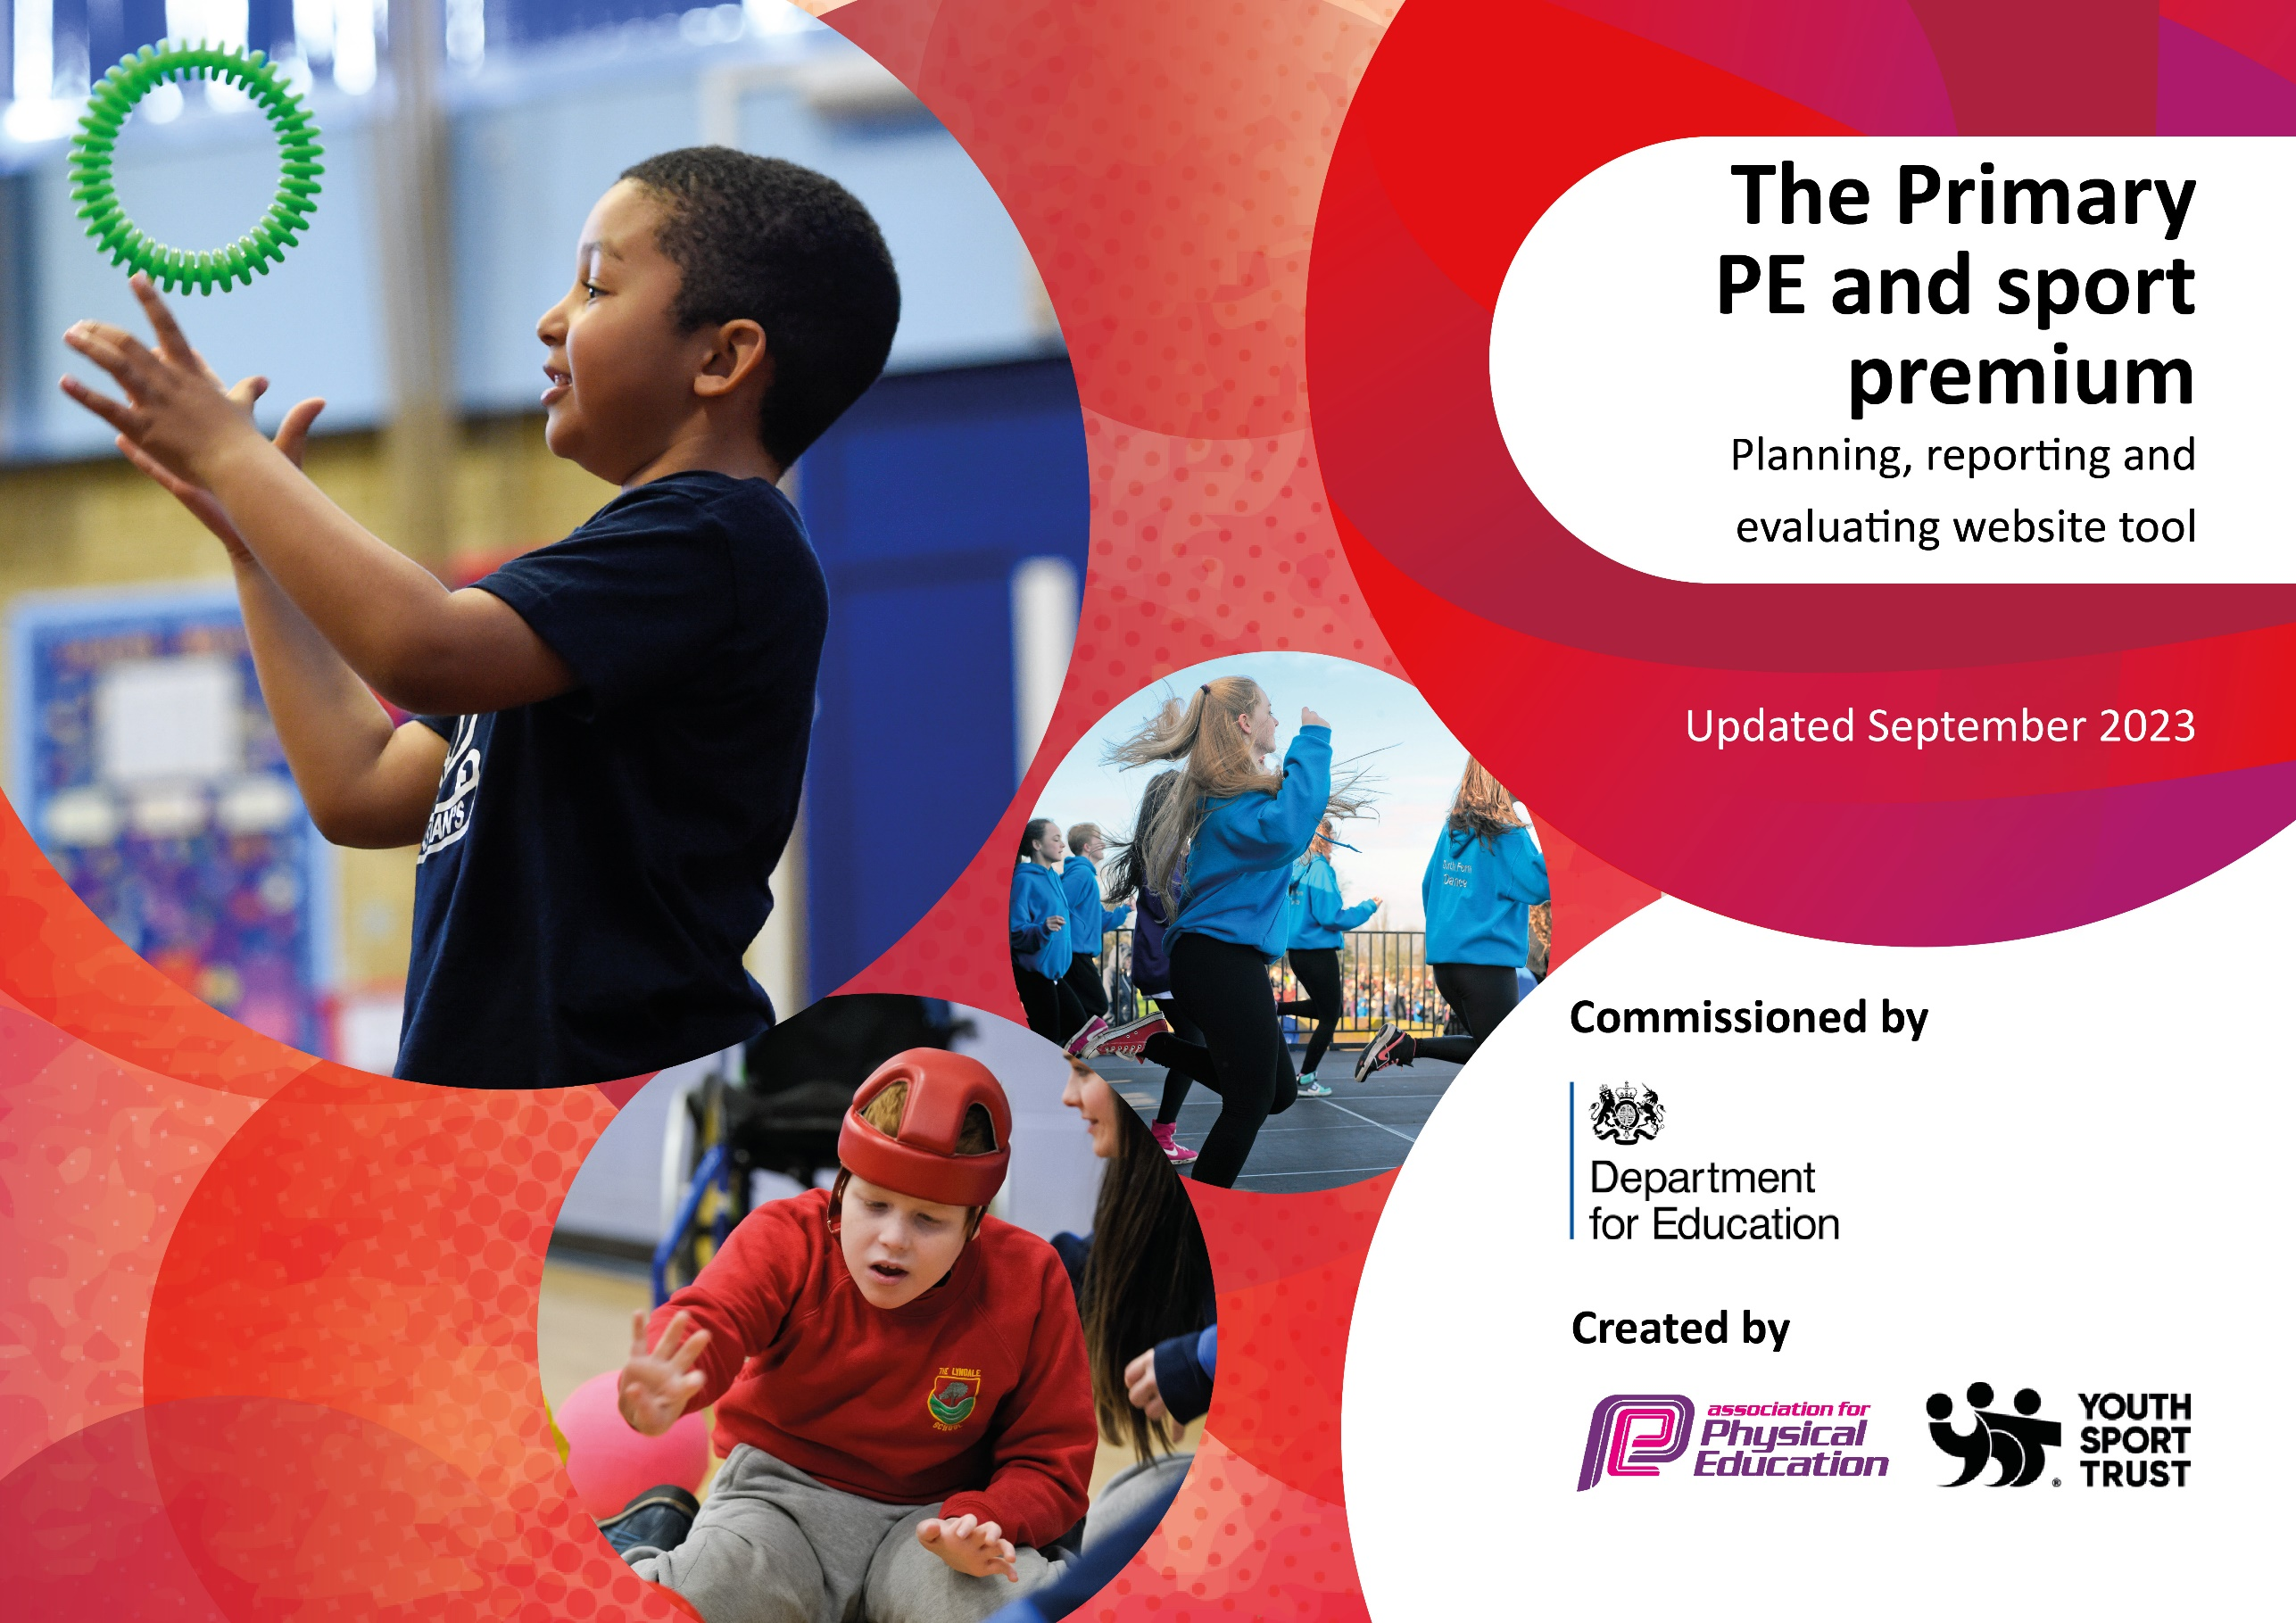

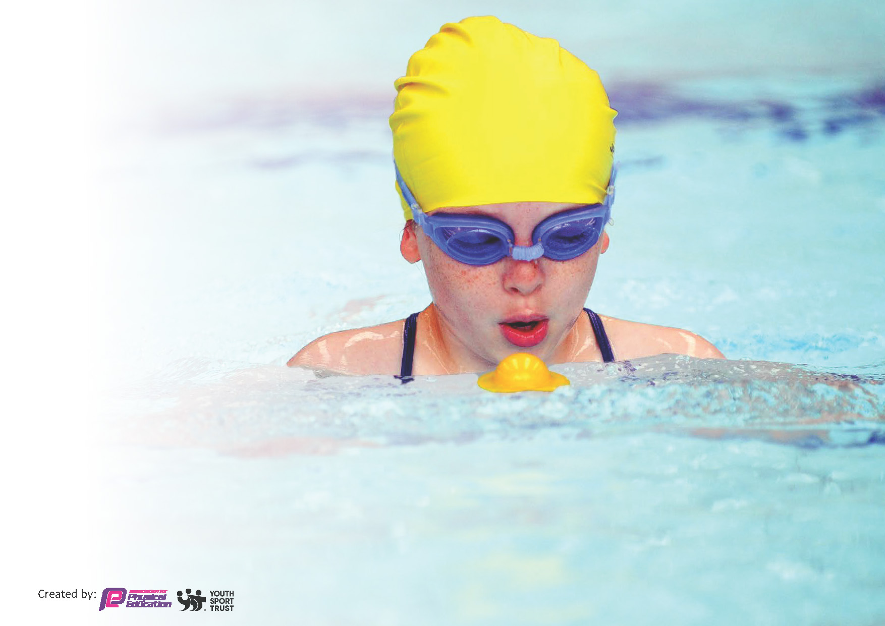
This template can be used for multiple purposes:
by:
- It enables schools to effectively plan their use of the Primary PE and sport premium
- It helps schools to meet the requirements (as set out in guidance) to publish information on their Primary PE and sport premium
- It will be an effective document to support Ofsted inspections enabling schools to evidence progress in Physical Education (PE) and evidence swimming attainment, which forms part of the PE National Curriculum. We would recommend schools consider
the Intent, Implementation and Impact of any spend, as examined within the Education Inspection Framework.

It is important that your grant is used effectively and based on school need.

Schools must use the funding to make additional and sustainable
improvements to the quality of the PE, School Sport and Physical Activity (PESSPA)
they offer. This means that you should use the Primary PE and sport premium to:

- Build capacity and capability within the school to ensure that improvements made now will benefit pupils joining the school in future years
- Develop or add to the PESSPA activities that your school already offers.

The Primary PE and sport premium should not be used to fund capital spend projects; the school’s core budget should fund these. Further detail on capital expenditure can be found in the updated Primary PE and sport premium guidance.

The Primary PE and sport premium guidance, outlines 5 key priorities that funding should be used towards. It is not

necessary that spending has to meet all the key priorities, you should select the priorities that you aim to use any funding towards.

Although completing this template is not a requirement for schools, schools are required to publish details of how they spend this funding. Schools must also outline what the impact this funding has had on pupils’ PE and sport participation and attainment and how any spending will be sustainable in the future. All funding must be spent by 31st July 2024.

The Department for Education has worked closely with the Association for Physical Education (afPE) and the Youth Sport Trust (YST) to develop this template and encourages schools to use it. This template is an effective way of meeting the reporting requirements of the Primary PE and sport premium.
Review of last year’s spend and key achievements (2022/2023)

We recommend you start by reflecting on the impact of current provision and reviewing your previous spend.

Activity/Action | Impact | Comments
Swimming provision  Bikeability  OPAL | All Year groups from Year 2 – 6 attended block swimming sessions. 90% of Pupils at Year 6 passed their 25m and water safety aspect of swimming.  Pupils accessing bikeability has increased 17% from previous year. Balance bikes will be introduced for EYFS in 2023.  Introducing the OPAL program in 2023-24. Funding to train staff and improve provision to improve playtime and lunch. | Due to the rising costs associate with swimming and transport the school can not afford a full year of swimming.  It has been decided to focus on Year 4-6. They will attend 6 sessions each.

Key priorities and Planning
This planning template will allow schools to accurately plan their spending.

Action – what are you planning to do | Who does this action impact? | Key indicator to meet | Impacts and how sustainability will be achieved? | Cost linked to the action
Introduce OPAL program to improve sport and activities at break and lunchtime. | Lunchtime supervisors / teaching staff, coaches - as they need to lead the activity  Pupils – as they will take part. | Key indicator 2 -The engagement of all pupils in regular physical activity – the Chief Medical Officer guidelines recommend that all children and young people aged 5 to 18 engage in at least 60 minutes of physical activity per day, of which 30 minutes should be in school.  Key indicator 4: Broader experience of a range of sports and activities offered to all pupils.  Key Indicator 3. The profile of PE and sport is raised across the school as a tool for whole school improvement. | Pupil voice survey indicates 82% increase in enjoyment at playtime. Range of activities has increased.  Tyre swings, exercise bars, balance beams, bikes, digging.  There are 14 new play offers.  Physical activity is increased to 30mins additionally per pupil. | £4999 costs for the program which includes mentor training and CPD for staff. Twilight INSETs booked for the coming year.  This also includes costs of equipment, storage and redesigned play areas.  Not all of the Sports Premium will cover the costs of this project.
Ensure all pupils participate in  primary school swimming to meet  requirements of NC by end of KS2. | Pupils – as they will take part. | Key Indicator 3: The profile of PE and sport is raised across the school as a tool for whole school improvement .  Key Indicator 2. Engagement of all pupils in regular physical activity |  | £4’900 cost for transport and 18 weeks sessions.
Take part and compete in Wheelchair Basket Ball. 6 Week sessions followed by a Trust wide tournament. | Pupils – Those who do not usual take part or compete | Key indicator 4: Broader experience of a range of sports and activities offered to all pupils.  Key Indicator 1: Increased confidence, knowledge and skills of all staff in teaching PE and sport | 100% participation across KS2.  Selection of children who have never competed for school selected to represent school at Trust level competition. | £2000 – For bespoke 6 week coaching sessions and CPD for staff.
Wider variety of after school sports  clubs available to all children | Pupils - as they will take part.  All disadvantaged pupils to be offered free places. | Key indicator 4: Broader experience of a range of sports and activities offered to all pupils.  Key Indicator 2. Engagement of all pupils in regular physical activity | Participation Register –  115 pupils attended these level 2 competitions amounting to 54% of the schools role participating. | Premier Sports afterschool coaches x2 a week.
A wider range of pupils have access to bikeability program to develop cycling proficiency and skills | EYFS – Balance Bike  Year 3/4 pupils – Level 1  Year 5/6 pupils Level 1 and 2 | Key indicator 4: Broader experience of a range of sports and activities offered to all pupils.  Key Indicator 2. Engagement of all pupils in regular physical activity | Level 1 participation 32% of Year ¾ have completed. Register keep to enable tracking of new groups for subsequent years.  58% Year 5/6 completed stage 2.  100% participation in EYFS balance bike. | £800 – For balance bike – EYFS only. Other sessions are free.
Ensure all pupils participate in  primary school swimming to meet  requirements of NC by end of KS2. | Pupils – as they will take part. | Key Indicator 3: The profile of PE and sport is raised across the school as a tool for whole school improvement .  Key Indicator 2. Engagement of all pupils in regular physical activity | 78% of Year 6 pupils achieve NCCSS Stage 7 | £4’900 cost for transport and 18 weeks sessions.
Organise and co-ordinate more sports  competitions and tournaments within  the school or intra-school to  encourage more children become  involved and enter.  Actively encourage pupils to  participate in school games.  Maintain high levels of attendance to  inter-school competitions and other  events available. | Pupils – as they will take part  Included in Broxtowe District Sports  - Indoor atheletics  - Boccia  - Cross Country  - Girls and Boys 7v7  - Chance to Dance  - Wheelchair Basket Ball  - Bowls  - Swimming Gala  - District Athletics  - Netball tournament | Key Indicator 3: The profile of PE and sport is raised across the school as a tool for whole school improvement .  Key Indicator 2. Engagement of all pupils in regular physical activity  Key indicator 4: Broader experience of a range of sports and activities offered to all pupils. | Participation Register - 154 pupils attended these level 2 competitions amounting to 54% of the schools role participating.  More events participated due to transport fees included. | £1000 – Transport costs

Key achievements 2023-2024
This template will be completed at the end of the academic year and will showcase the key achievements schools have made with their Primary PE and sport premium spending.

Activity/Action | Impact | Comments
Increase awareness and understanding of healthy lifestyles and activities with KS1 and KS2 pupils.  Increase awareness of healthy diets and healthy eating through bespoke healthy schools eating program in KS1 + KS2.  Provide opportunities for pupils to engage in a variety of activities outside the school through district competition and engagement. More opportunities to compete in level 1 and level 2 sports competition  Extend provision into across school through additional afterschool clubs provided by Premier Sports  Swimming provision for KS2 pupils to improve water confidence  Increased provision and offer of activities through OPAL. | Wider play offer. 14 new play types which include balance, strength. Greater participation levels, additional 30 minutes activity per pupil each day.  More opportunities to compete in level 1 and level 2 sports competition.  Teacher confidence in teaching PE increased CPD given for target areas particularly in KS2  Uptake in KS1 excellent. KS2 numbers varied based on activity provided | Ongoing costs to replace equipment.  Maintain and train staff.  Rising costs of transport and closure of local swimming pool will impact on the number of pupils swimming and achieving level 7 may reduce.  Continue afterschool provision and look to enhance other offers before school and during lunchtime clubs.  Engage KS2 in sports offer afterschool – Expand range.

Swimming Data
Meeting National Curriculum requirements for swimming and water safety.
Priority should always be given to ensuring that pupils can perform safe self-rescue even if they do not fully meet the first two requirements of the National Curriculum programme of study

Question | Stats: | Further context  Relative to local challenges
What percentage of your current Year 6 cohort can swim competently, confidently and proficiently over a distance of at least 25 metres? | 78% Year 6  62% Year 5  32% Year 4  38% Year 3 | Raising transport costs this year meant we were quoted £11’325 for our swimming provision. This was unsustainable. We have reduced this to £4’540. The local swimming pool is also closing which will present further challenges next year.
What percentage of your current Year 6 cohort can use a range of strokes effectively [for example, front crawl, backstroke, and breaststroke]? | 78% Year 6

What percentage of your current Year 6 cohort are able to perform safe self-rescue in different water-based situations? | 78%
If your schools swimming data is below national expectation, you can choose to use the Primary PE and sport premium to provide additional top-up sessions for those pupils that did not meet National Curriculum  requirements after the completion of core lessons. Have you done this? | No
Have you provided CPD to improve the knowledge and confidence of staff to be able to teach swimming and water safety? | No | This is included in the provision we buy into. Additional water safety assemblies and sessions taught within school by outside providers.

Signed off by:

Head Teacher: | Ben Painter
Subject Leader or the individual responsible for the Primary PE and sport premium: | Ben Painter
Governor: | Hannah Adkin-Walker
Date: | Action plan implemented September 2023  Reviewed July 2024

